***ADVANCED PHYSICAL DESIGN USING OPENLANE/SKY130***

Here is the complete report of the workshop using Google-SkyWater within the OpenLANE.

* **Table Contents:-**

1. SKY130 DAY1:-Inception of open-source EDA, OpenLANE and Sky130 PDK

* D1_SK1:-How to talk to computers?
* L1-Introduction to QFN-48 Package, chips, pads, core , die and IPs
* L2-Introduction to RISC-V
* L3-From Software Applications to Hardware
* D1_SK2-Soc design and OpenLANE
* L1-Introduction to all components of open-source digital asic design
* L2-Simplified RTL2GDS flow
* L3-Introduction to OpenLANE and Strive chipsets
* L4-Introduction to OpenLANE detailed ASIC design flow
* D1_SK3- Get familiar to open source EDA tools
* L1-OpenLANE Directory structure in detail
* L2- Design preparation step
* L3-Review files after design prep run synthesis
* L4-OpenLANE project Git link Description
* L5- Steps to characterize synthesis results

1. SKY130DAY2:-Good floorplan vs bad floorplan and introduction to library cells

* D2_SK1:-Chip floor planning considerations
* L1:-Utilization factor and aspect ratio
* L2:-Concept of pre placed cells
* L3:-De coupling capacitors
* L4:-Power planning
* L5:-Pin placement and logical cell placement blockage
* L6:-Steps to run floorplan using OpenLANE
* L7:-Review floorplan files and steps to view floorplan
* L8:-Review floorplan layout in Magic
* D2_SK2:-Library Binding and placement
* L1:-Netlist binding and initial place design
* L2:-Optimize placement using estimated wire length and capacitance
* L3:-Final placement optimization
* L4:-Need for libraries and characterization
* L5:-Congestion aware placement using RePlAce
* D2_SK3:-Cell design and characterization parameters
* L1:-Inputs for cell design flow
* L2:-Ciruit design step
* L3:-Layout design step
* L4:-Typical characterization flow
* D2_SK4:-General timing characterization parameters
* L1:-Timing threshold definitions
* L2:-Propagation delay and transition time

1. SKY130DAY3:-Design library cell using Magic Layout and ngspice characterization

* D3_SK1:-Labs for CMOS inverter ngspice simulations
* IO Placer Revision
* SPICE Simulation lab for CMOS Inverter
* Switching Thershold VM
* Static and dynamic simulation of CMOS inverter
* Lab steps to GitClone VSDSTD cell design
* D3_SK2:-Inception of layout A CMOS Fabrication process
* Create active Regions
* Formation Of N and P well
* Formation of Gate Terminal
* Lightly doped drain formation
* Source A drain Formation
* Local Interconnect Formation
* Higher level Metal Formation
* Lab Introduction to sky130 Basic layers layout and LEF using inverter
* Lab steps to Create STD cell layout and Extract SPICE Netlist
* D3_SK3:-SKY130 Tech File LABS
* Lab steps to create final SPICE deck using SKY130 tech
* Lab steps to characterize inverter using SKY130 Model files
* Lab introduction to SKY10 PDK’s And steps to download labs
* Lab introduction to Magic Tools options and DRC rules
* Lab exercise to fix poly.9 error in SKY130 Techfile
* Lab exercise to implement Poly-Resistor spacing to diff and Tap

1. SKY130 DAY4:-Pre layout Timing Analysis and importance of good clock tree

* Timing modeling using delay tables
* Timing Analysis with ideal clocks using Open STA
* Clock tree synthesis Triton CTS and signal integrity
* Timing analysis with Real clocks using Open STA

1. SKY130 DAY5:-Final Steps for RTL2GDS using TritonRoute and OpenSTA

* Routing and design check(DRC)
* Power Distribution network and routing
* Triton Route features

**1.SKY130 DAY1:-**

HOW TO TALK TO COMPUTERS:-

*INTRO TO QFN-48 ,PACKAGE ,CHIPS ,ETC;-*

It is an extensively used circuit board that is ARDUINO. Which can be seen in the figure below

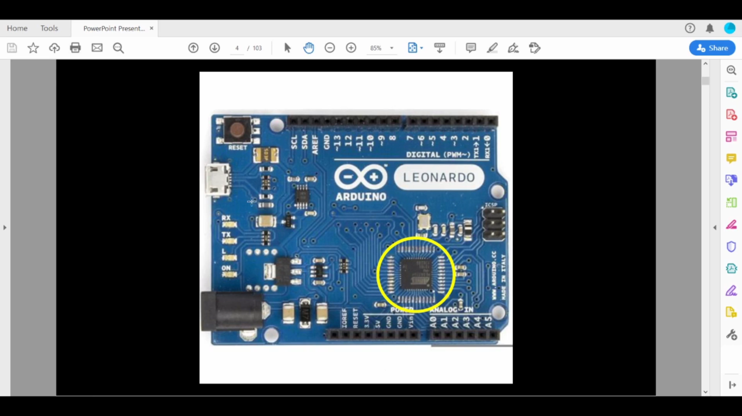It is a processor i.e system on Chip. The main part in chip rounded with yellow colour

The yellow region can been seen through some diagram known as BLOCK DIAGRAM show in below

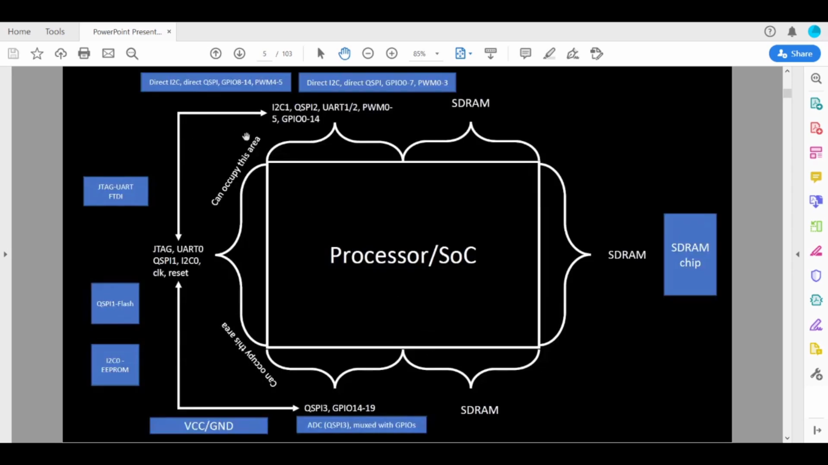

From the picture we can some big boxes which are known as SoC . From the layman’s terms it is mainly called as CHIP. Termed as PACKAGE, which is mainly used arduino board

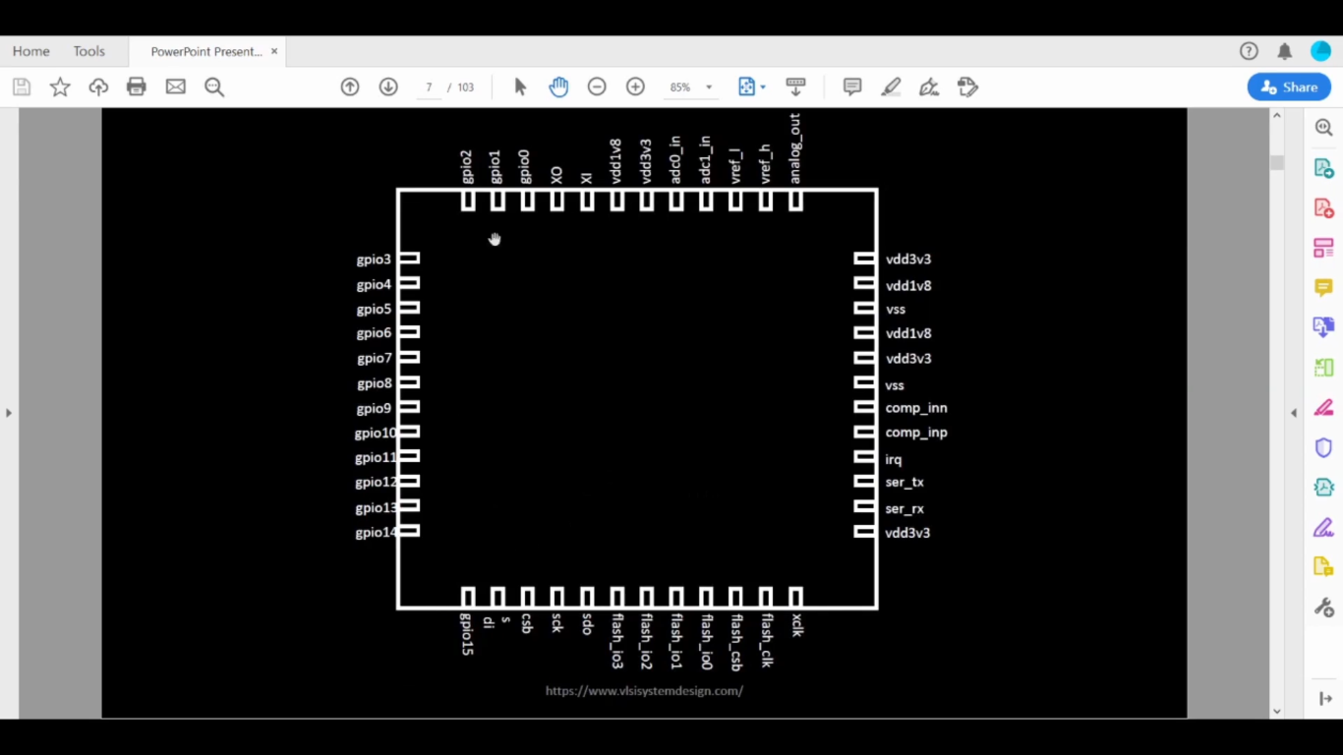 PACKAGES can be represented mainly from the above figure:-

As observed chip is an inside package which is connected mainly to various PINS or may be also known inputs/outputs.

A chip has some various existing components as following:-

* PADS:-They are connecters between circuit and chips
* CORE:-This is the digital logic with some gates in that such as AND, NOR .
* DIE:- It is a part of semiconductor wafer that can be used in devices.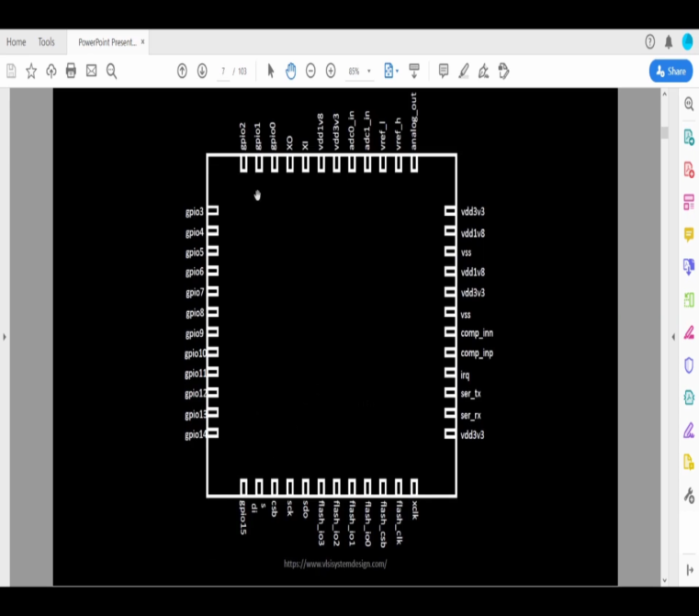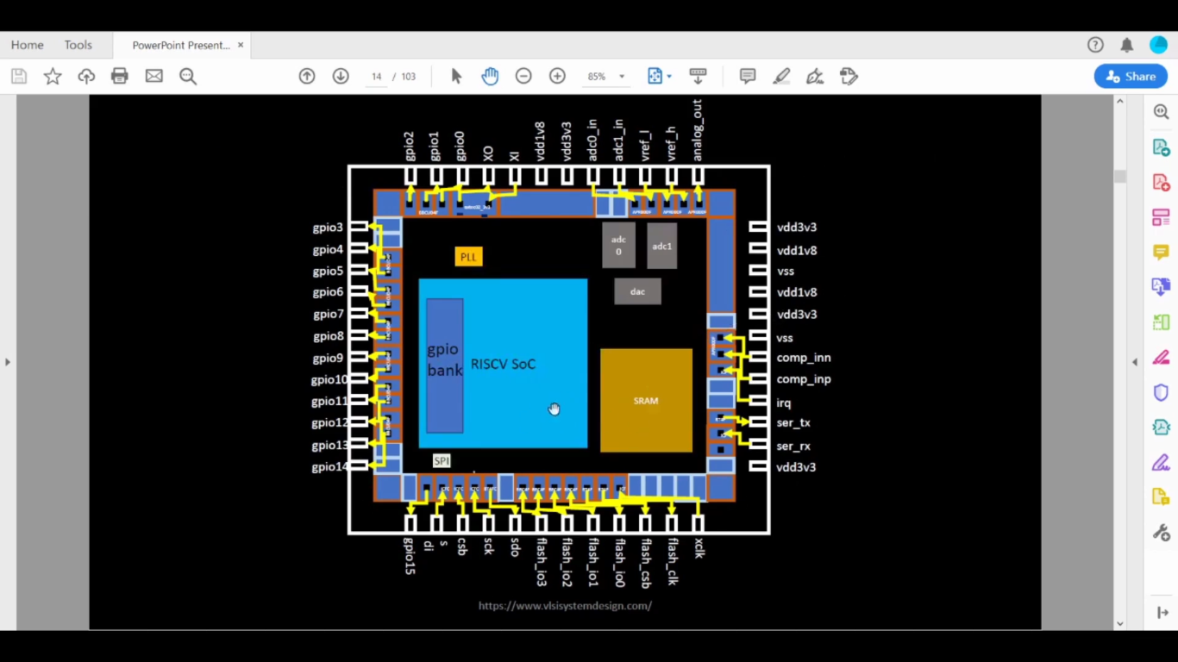

This is schematics of RISC with some various components in that such as FOUNDARY IPs, MACROs.

*INTRODUCTION TO RISC V:-*

The full form of RISC V is Instruction set Architecture which is the language in computer. If C program must be runned than this RISC V is complied.

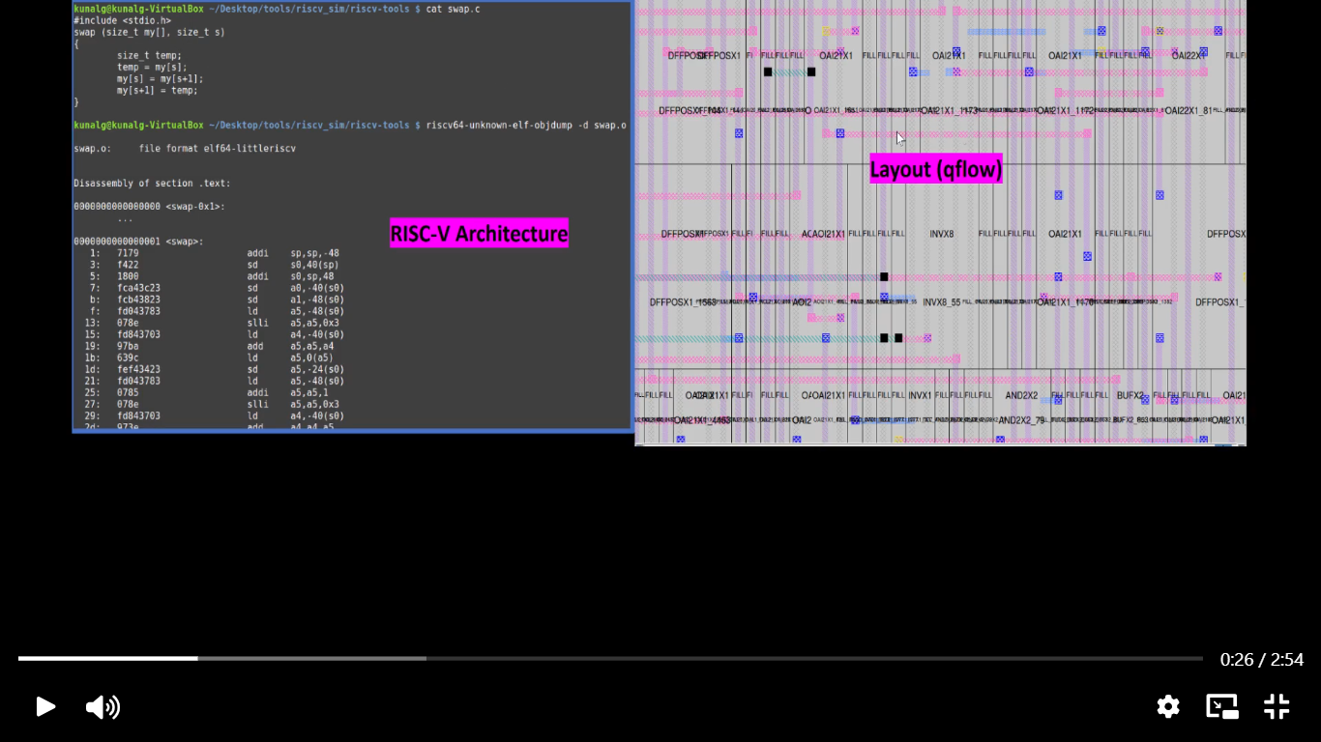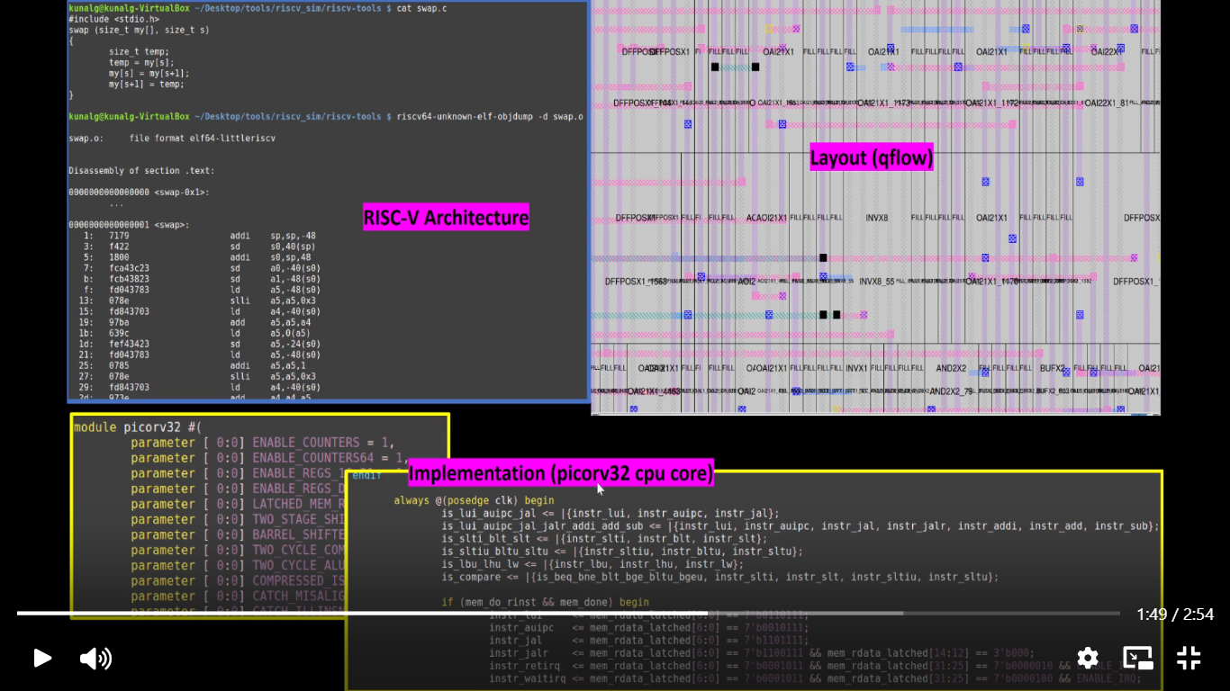

*FROM SOFTWARE APPLICATIONS TO HARDWARE:-*

*It is also known as APPS. They basically run on hardware such as laptops, phones, etc.*

*This is by system software that is majorly:-*

* *Operating system*
* *Compilers*
* *Assemblers*

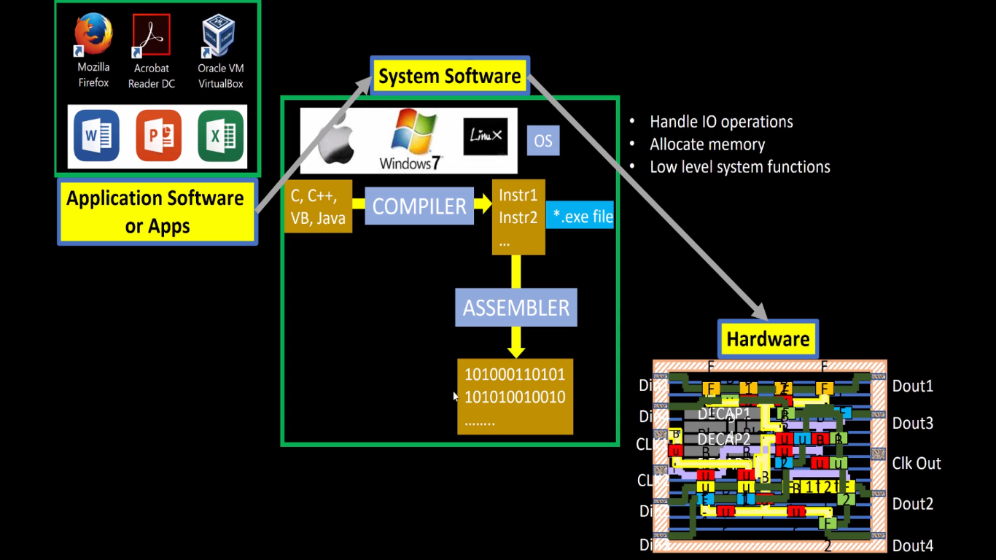

***SoC Design And OpenLANE:-***

*Introduction to components of opensource Digital AISC Design:-*

*It requires some basic components that 3parts:-*

1. *RTL IPs: These are blocks which are in the form of hardware language.*

*They state as functioning unit .*

1. *EDA Tools:- Full form is Electronic Design Automation tools .These are required for designing , simulators etc. Some tools like OpenSTA , OpenRoad are mainly used .*
2. *PDK data:- Full form is Process Design Kit data which is the collection of used files in model for EDA tools.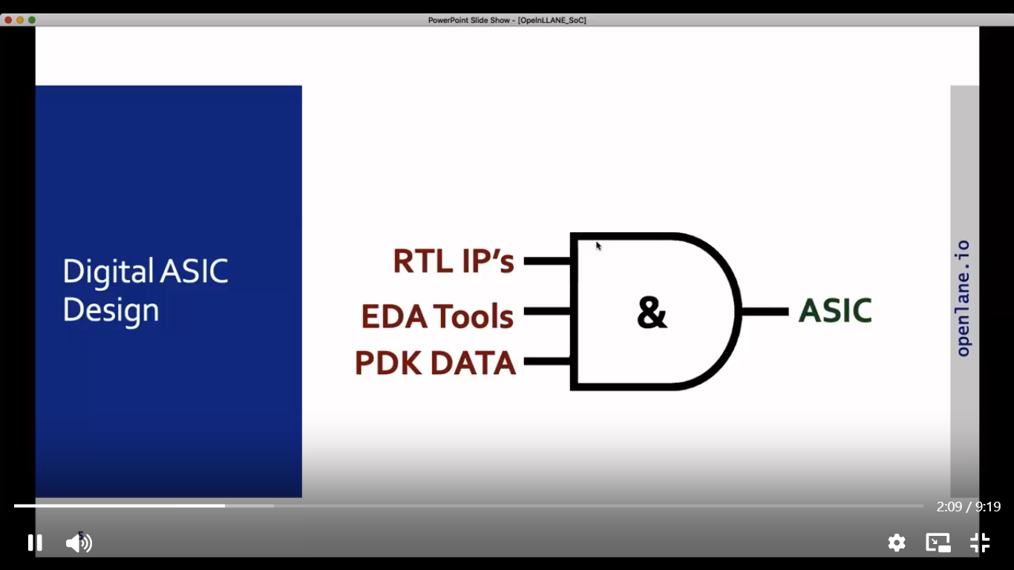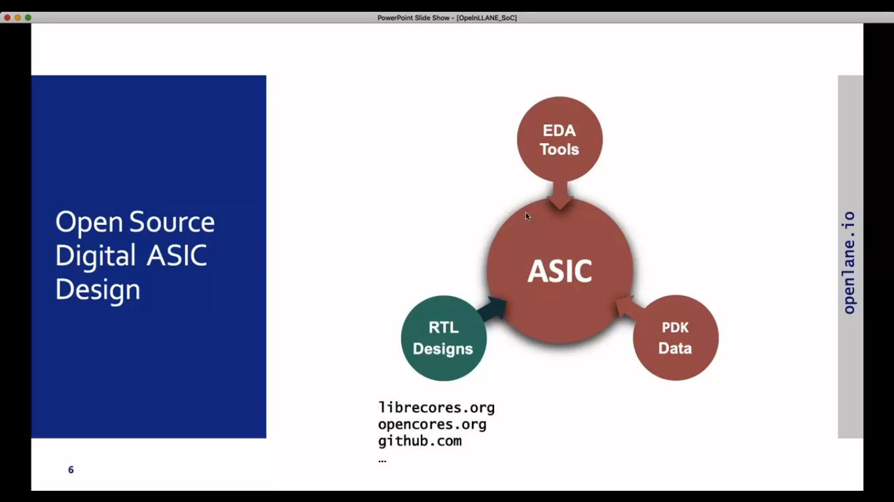*

***SIMPLIFY RTL TO GDS FLOW:-***

***RTL:-Register transfer level***

***GDS II:- Graphic design system II***

***Synthesis is the hardware which changes some language that is VERILOG to gates. Some cell library is used for regular layout like Spice and HDL etc***

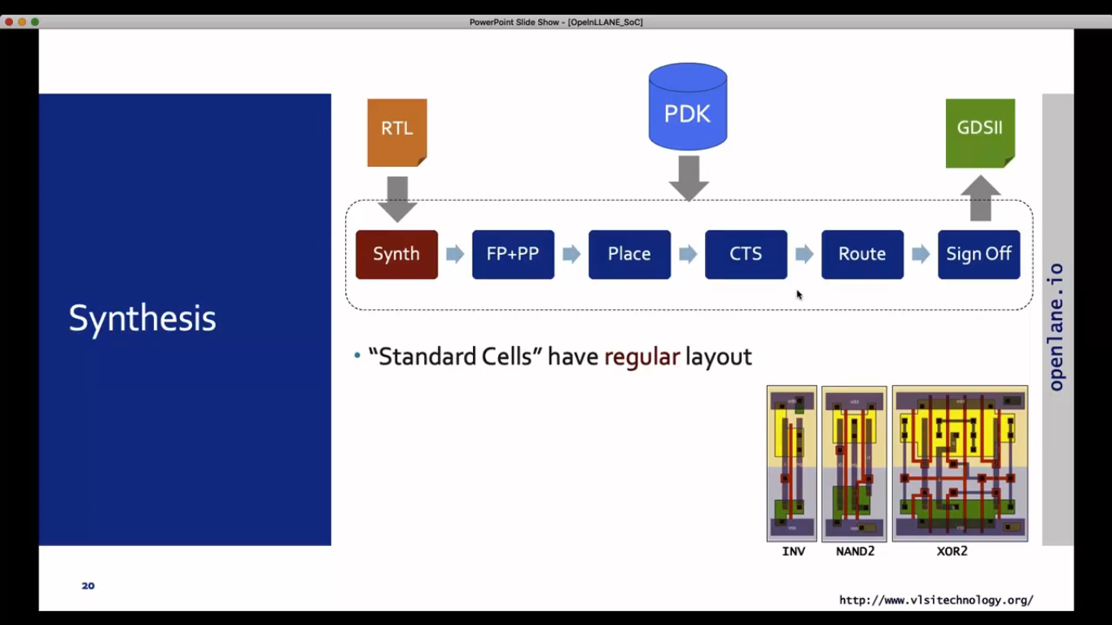

***The next part is floorplanning:-***

***This mainly involves in optimization of chip working, area and some arrangements .***

***Some important use of floorplanning is Wire length, Signal delays , Power these all are roughly reduced . Chip utilization also plays an important role. The main usage of this is PDN i.e power distribution networks.***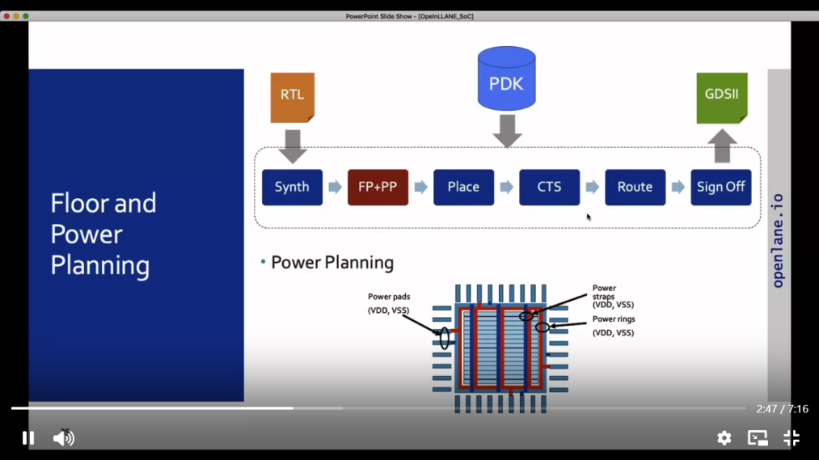

***Placement:- This is the process were determing components of chips. Which include cells, macros, and I/O pads.***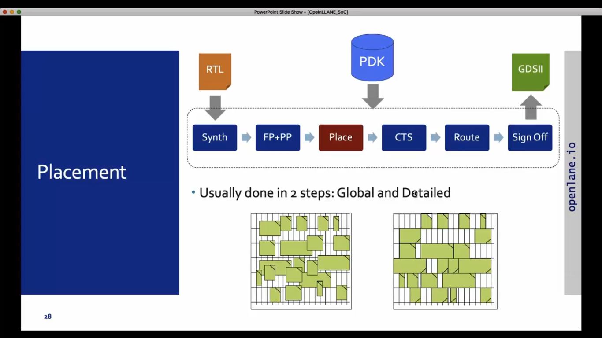

***Clock TREE Synthesis:- THIS PROGRESS IS DONE 1ST OF ROUTING TO ALL SEQUENCE ELEMENTS.***

***ROUTING:- It is the determining of interconnenctions of all components such as metal layers pitch etc.***

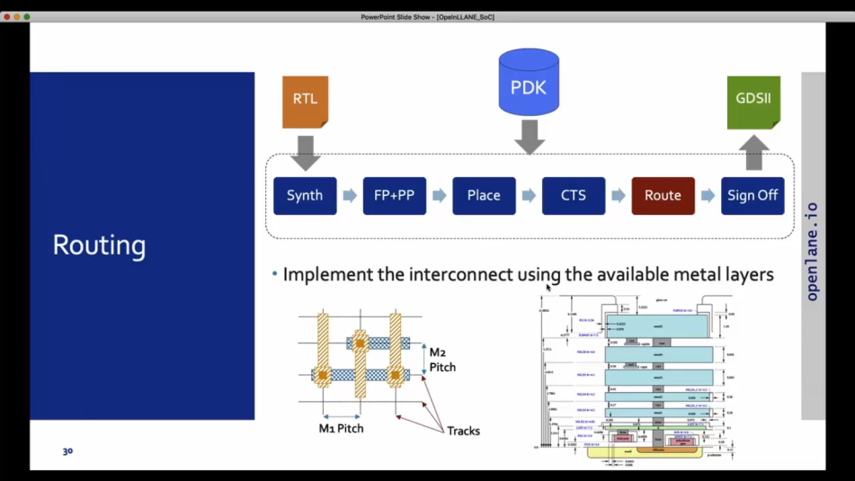

***Sign off has some verification through various process such as design rule(DRC), Layout vs Schematic(LVS), Static Timing Analysis(STA).***

***Intro TO OpenLANE and Strive Chipsets:-***

***This is digital web were AISC is joint with google flow.***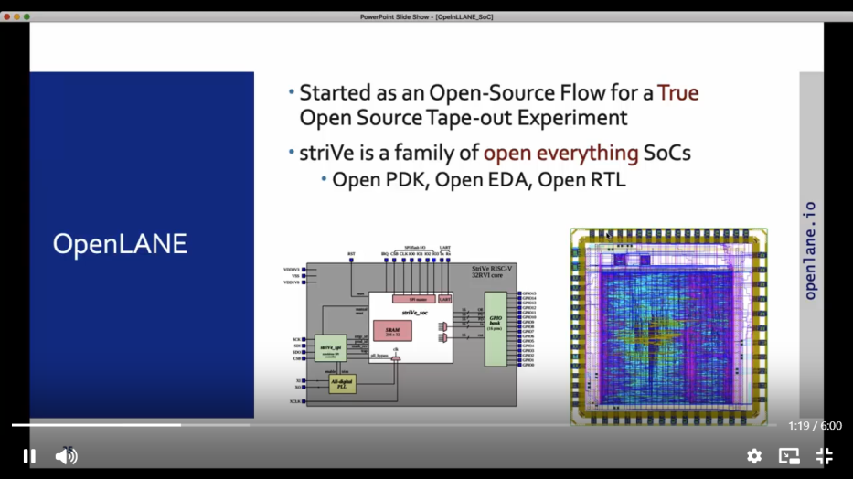

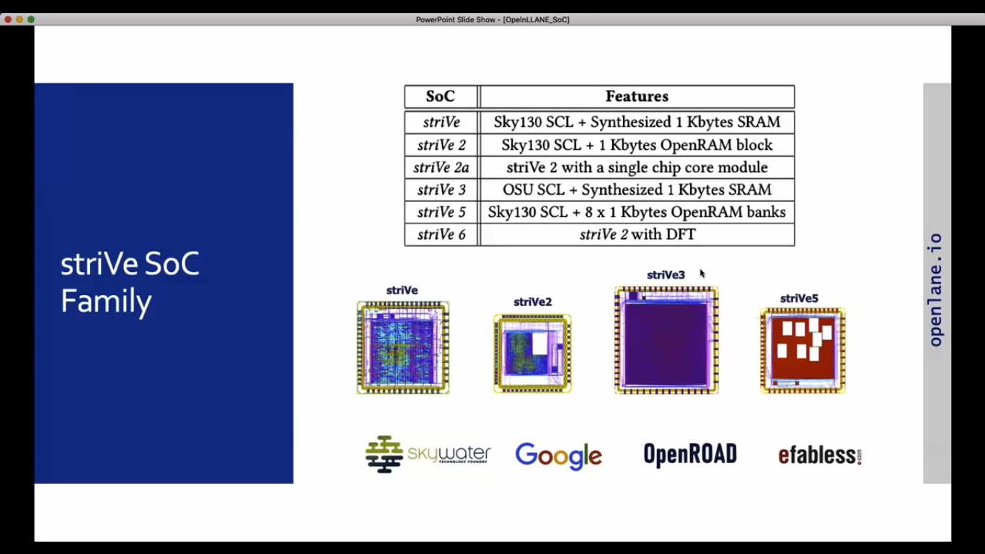

***THE STRIVE SOC has some components like Efabless.***

***INTRODUCTION TO OPENLANE WITH ASIC DESIGN FLOW***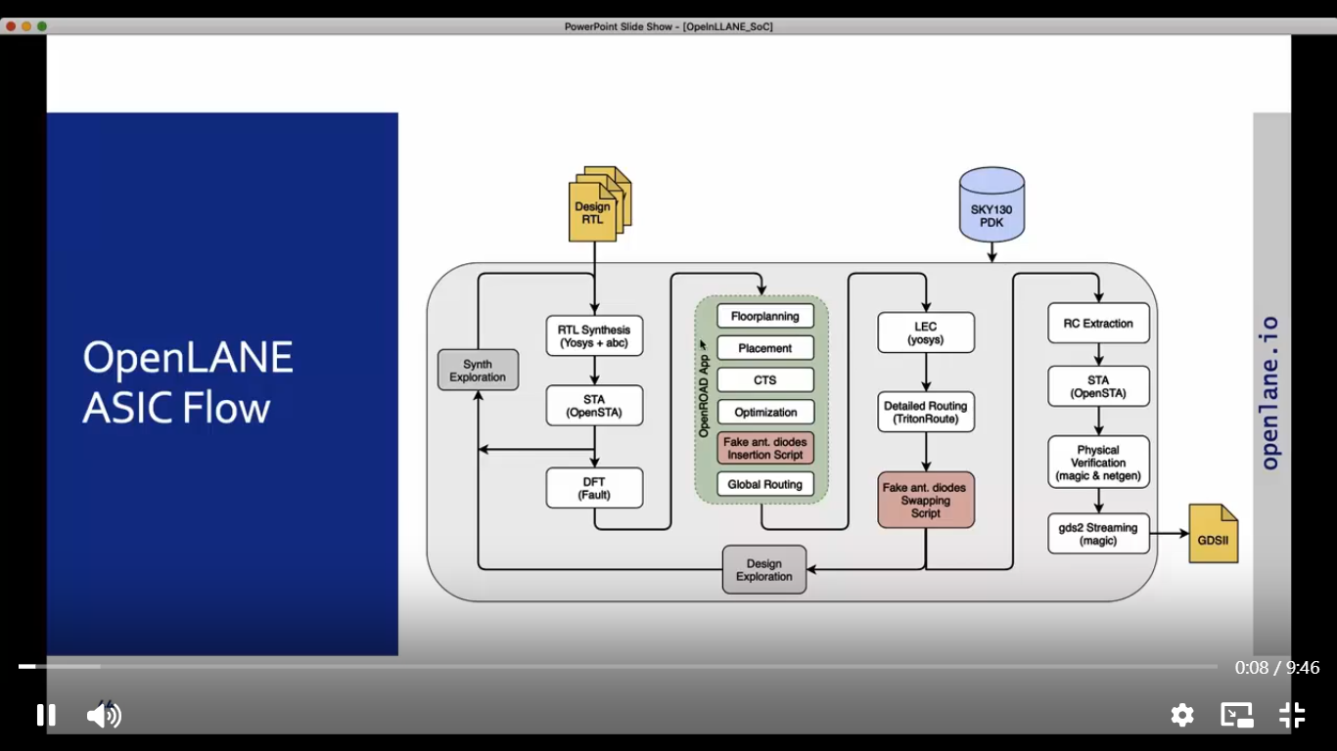

***THERE IS SOME EXPLORATION SUCH AS DESIGN AND SYNTHESIS***

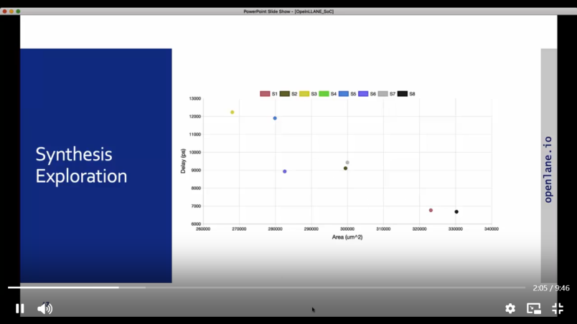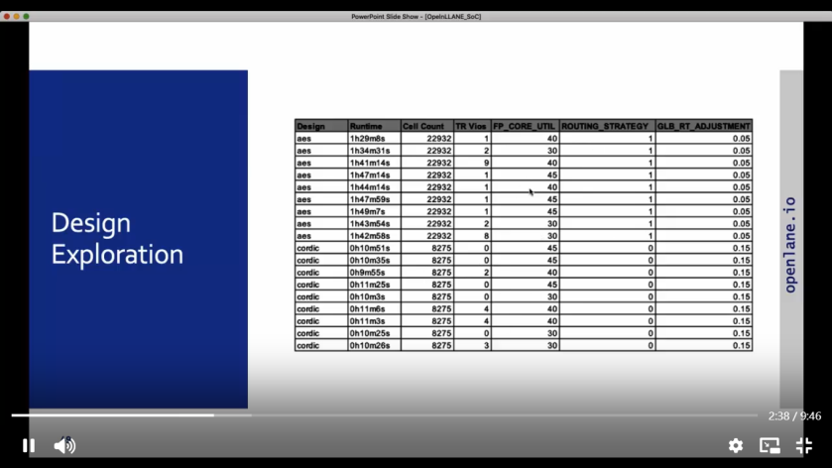

***OpenLANE Regression Testing way:-Design for test(DFT)***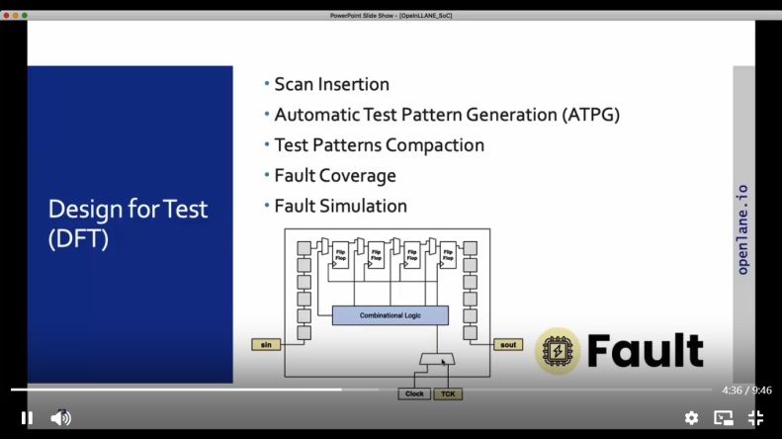

*Physical Verify (DRC AND LVS):-Magic for DRC and Magic And Negeten for LVS*

*Logic Equivalence Check(LEC)-Checking of physical implementation and netlist in some logic.*

***DEALING OF SOME ANTENNA RULES:-***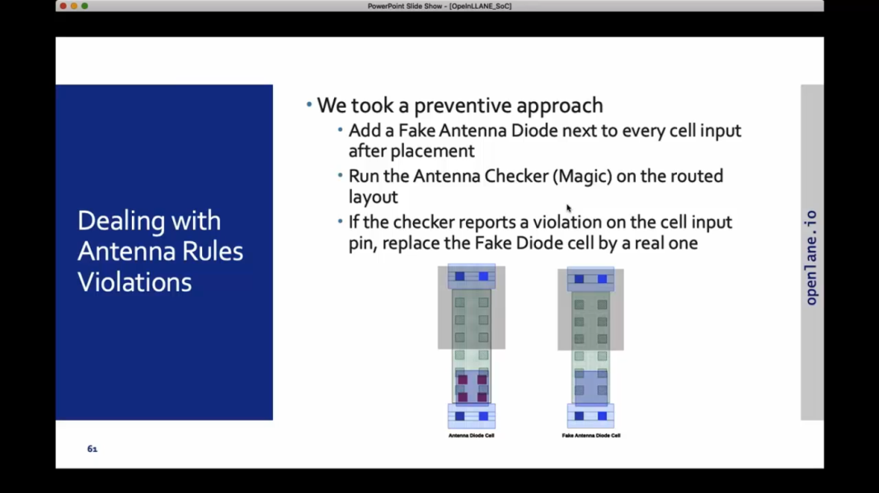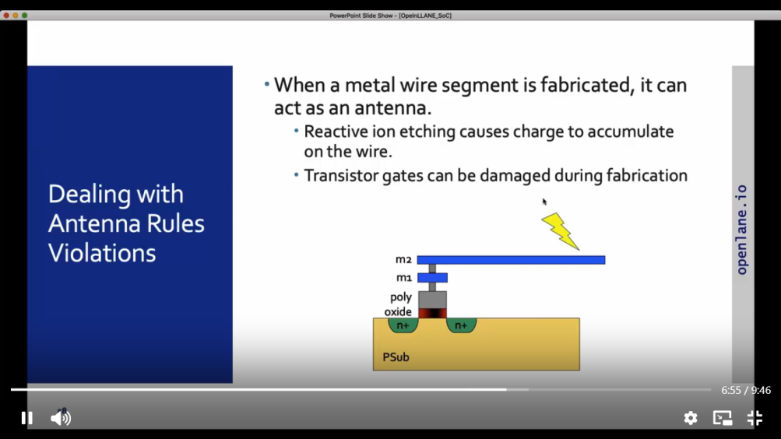

***GETTING FAMILIAR TO OPENSOURCE EDA TOOLS:-***

*It is more than tool type consisting of various opensource. Lets explore this tool for extent…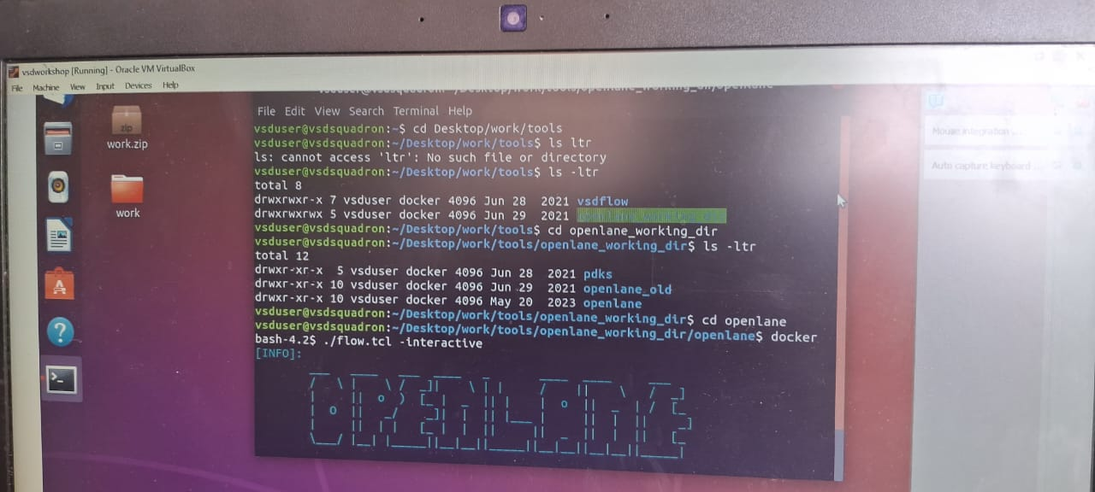*

* *Open virtual machine*
* *Type cd deskstop/work/tools*
* *Type ls –ltr*
* *In this program lets select openlane_working_dir as shown in above fig which from present working laptop*
* *WE are going to even check with pdk and sky130 in other terminal and also with libs.tech and magic directory command*
* *Type docker*
* *The display shows as BASH type ./flow.tcl –interactive*

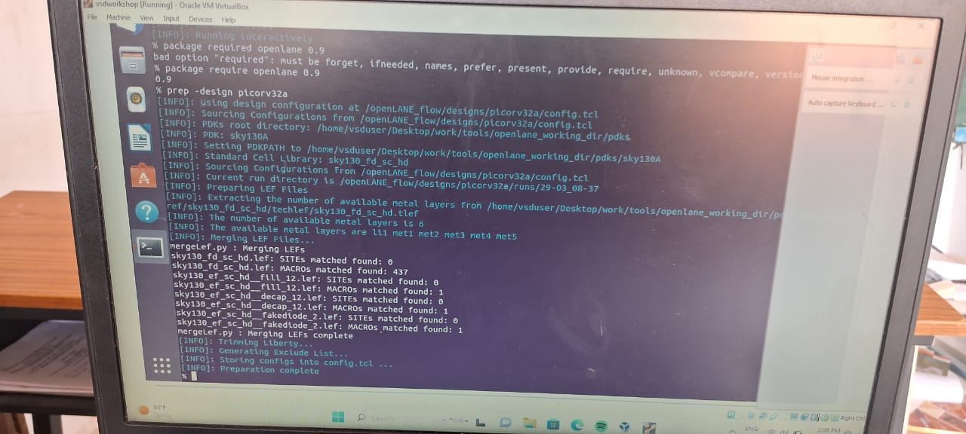

* *After the display of OPENLANE we are good to go with program.*
* *As we are interested in picorv32a will go with that*
* *Ones the preparation is done type run synthesis which can take few minutes*

*THESE ALL COMANDS ARE EXTRACTED FROM SOME TERMINAL SUCH AS MEREGED.LEF, RUNS COMMAND, ETC*

*Once the synthesis is done we can see this way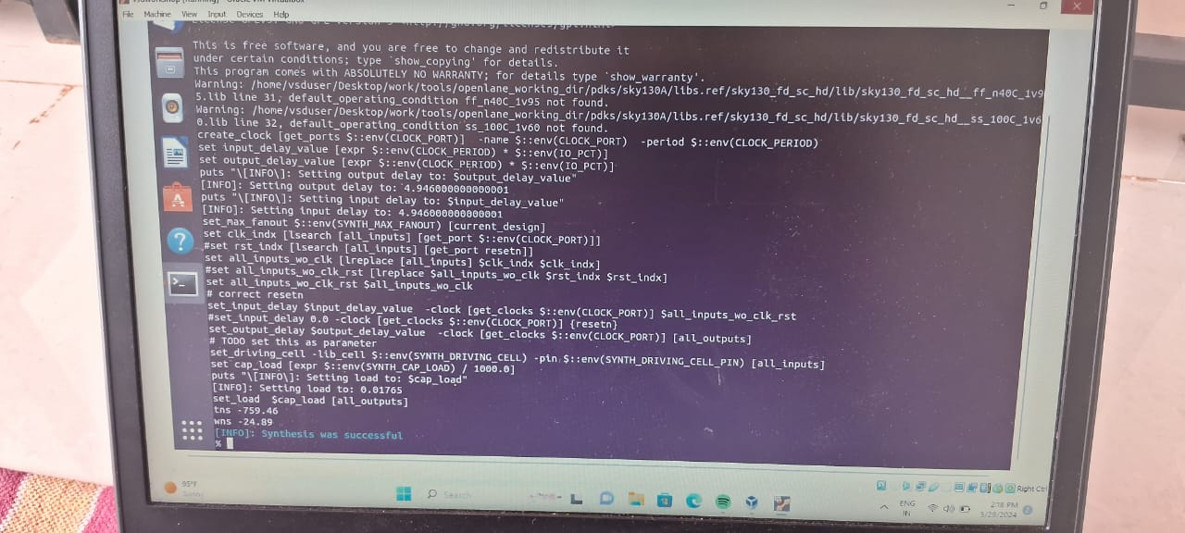*

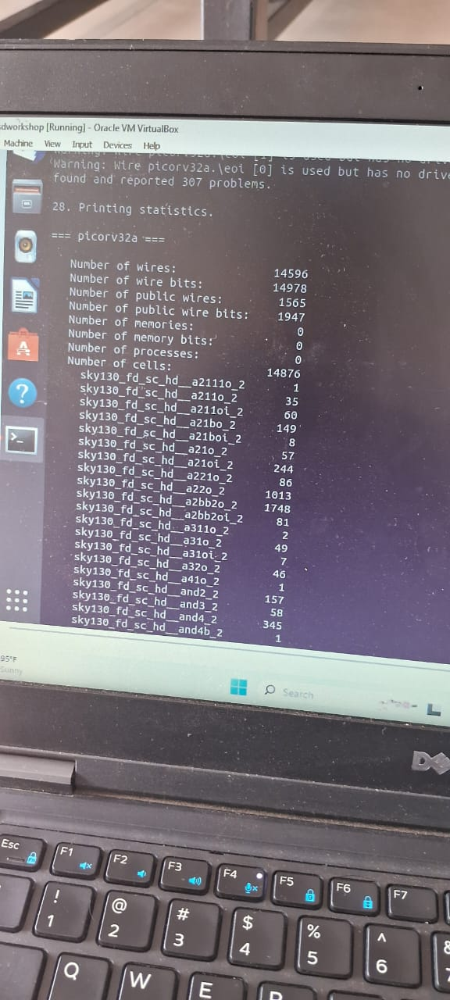

***Chip floor planning considerations:-***

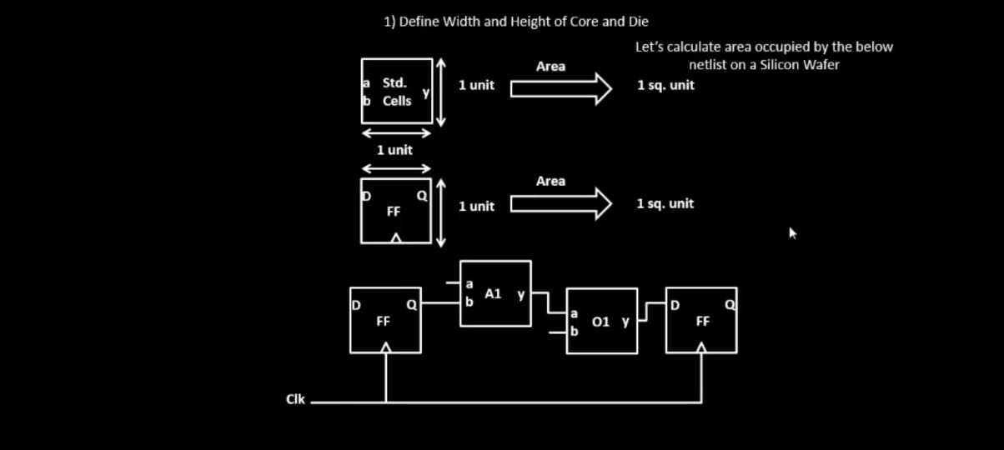

*In this the basic step is to define width and height of core and die.*

*For example :-1unit*1unit which 1sq units in size*

*All the gates will be there in core of chips and part of die*

***Utilisation factor=area occupied in netlist/total area core.***



*The aspect ratio as per above picture is =2:4=0.5*

***Concept of preplaced cells:-***

*These are complexive logic boxes or blocks which are reused.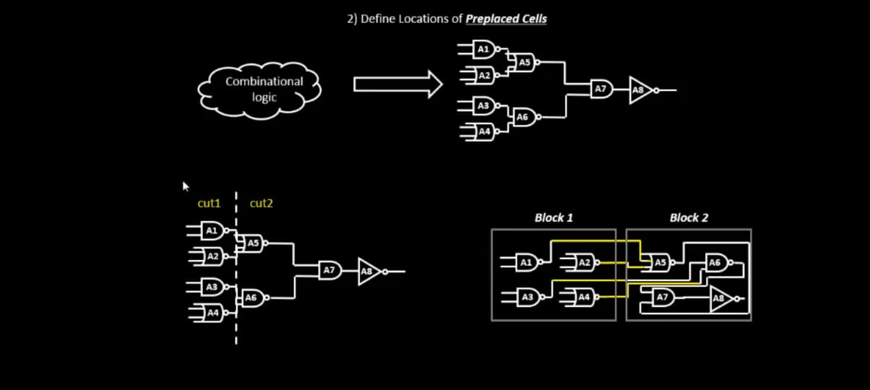*

*The combinational logic gives some particular functions. By extending IO pins we can convert logic into 2 parts. Some arranging og IPs in chip is mainly known as floorplanning*

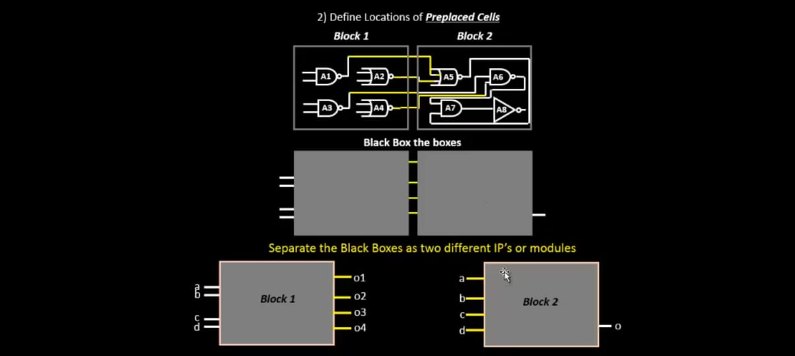

***DE-COUPLING CAPACITORS:-***

*IT is the solution to preplaced cells with this method. The capacitors can be as huge completely filled of charges.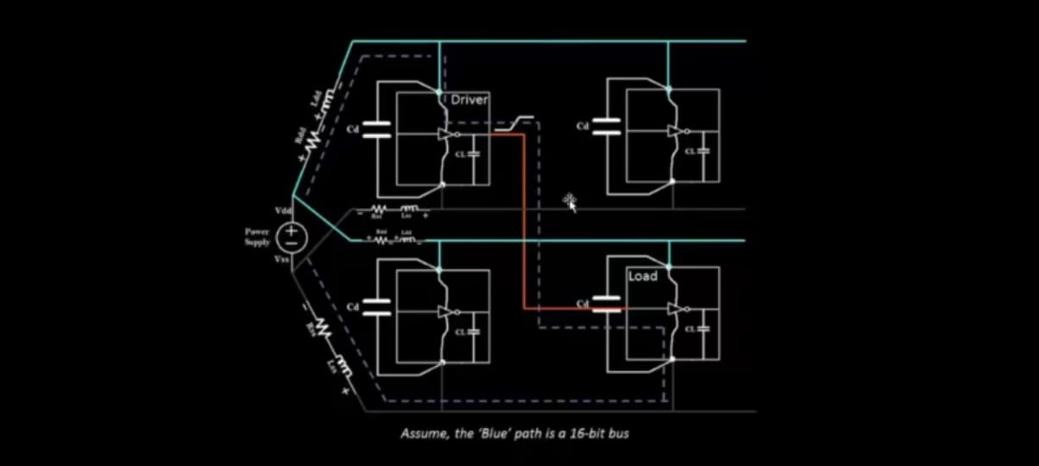 The example for De coupling capacitors shown in figure:-*

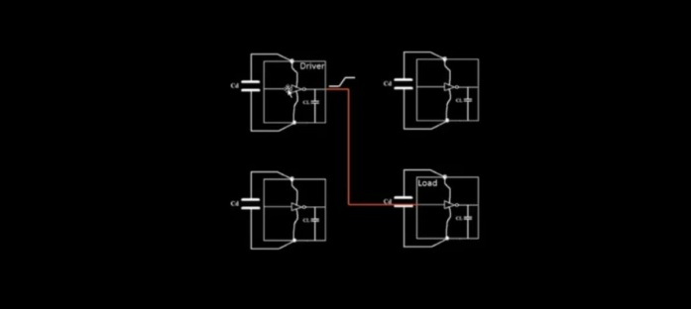

***Pin-placement abd logical cell placement blockage:-***

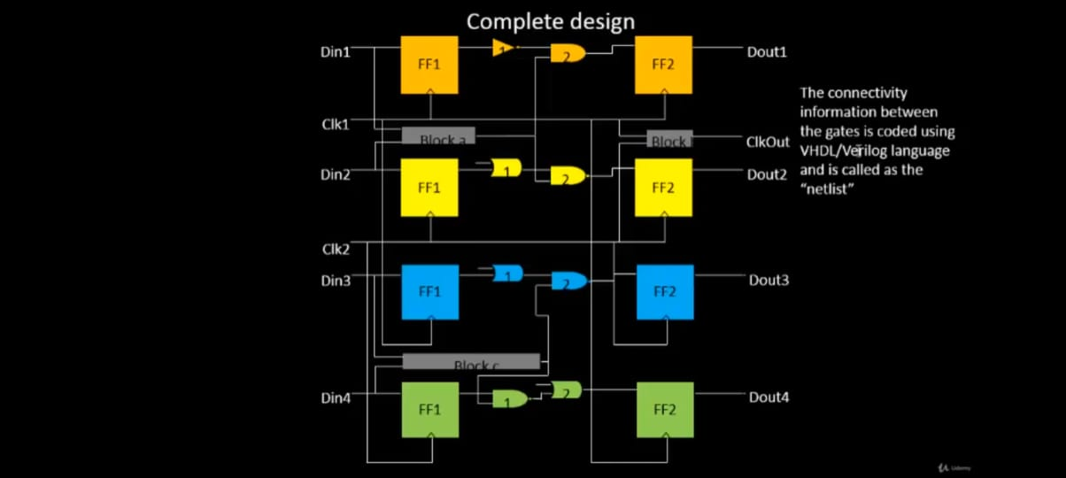

***This info is taken from connections of code called as VERILOG. THE SIZE IS INVERSLY PROPORTIONAL TO RESISTANCE.***

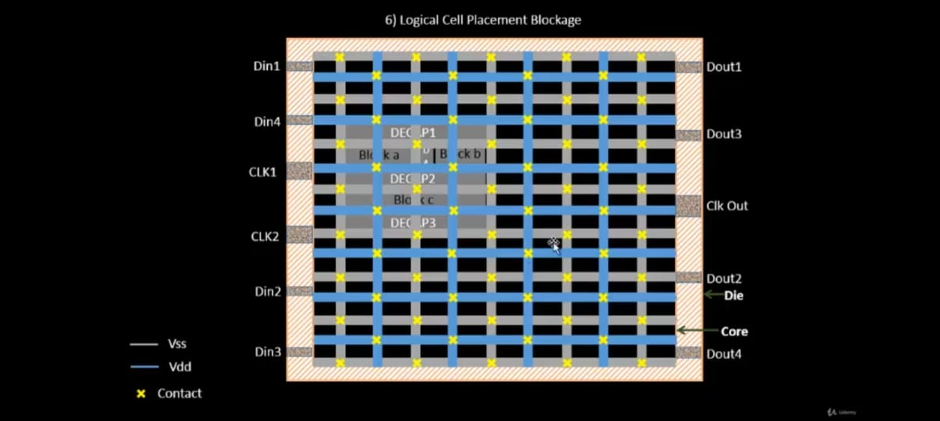

*PINNING AFTER we can create logical cell placement blockage.****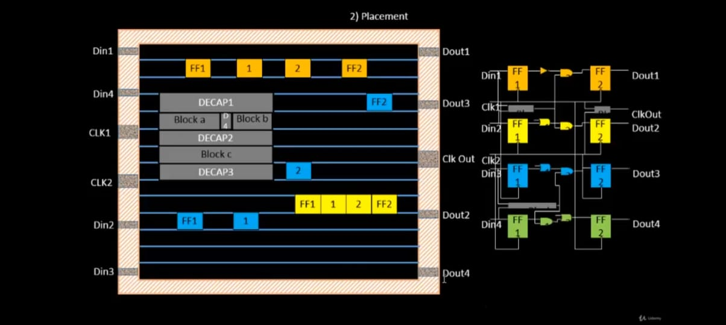***

*Optimization of placement using wire-length and capacitance .Tthe stage where the wirelength and capacitance (C=EA/d). If the wirelength is more, then to maintain signal integrity, we add repeaters to reduce resistance. Repeaters are basically reconditions the original signal and transfers.*

*Run placement on OpenLane: % run_placement*

*This commmand is that which global placement ,*

*Placement is done in two stages mainly are;*

*• Global Placement : There is no legalization takes place and which uses Half Perimeter Wirelength (HPWL) reduction model.*

*• Detailed Placement : legalization happens where the standard cells are placed in stadard rows, and there will be no overlaps of the cells. .*

*When the placement runs refer to these link for further step*

*/openlane/designs/picorv32a/runs/date/results/placement/picorv32a.placement.def Command: magic -T /home/vsduser/Desktop/work/tools/openlane_working_dir/pdks/sky130A/libs.tech/magic/sky130A.tech lef read ../../tmp/merged.lef def read picorv32a.placement.def*

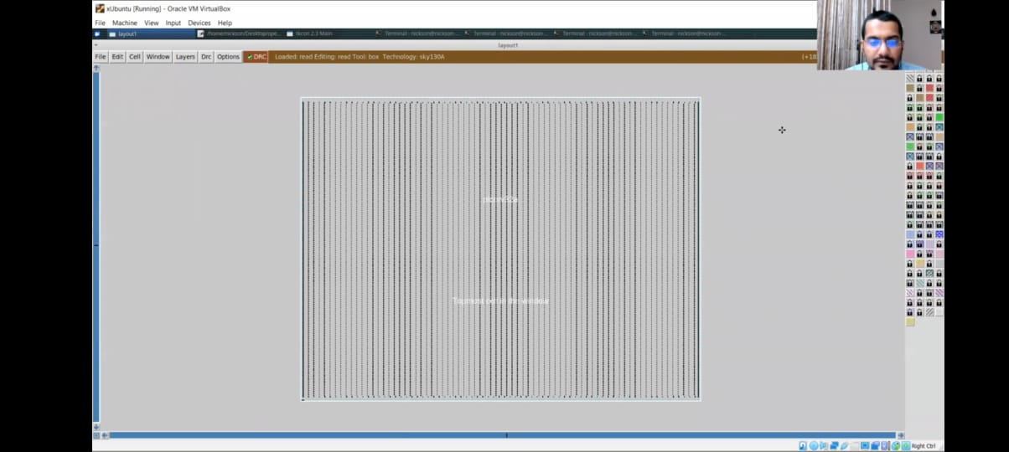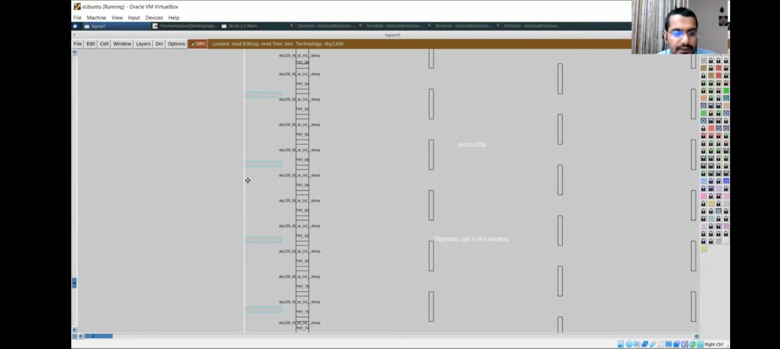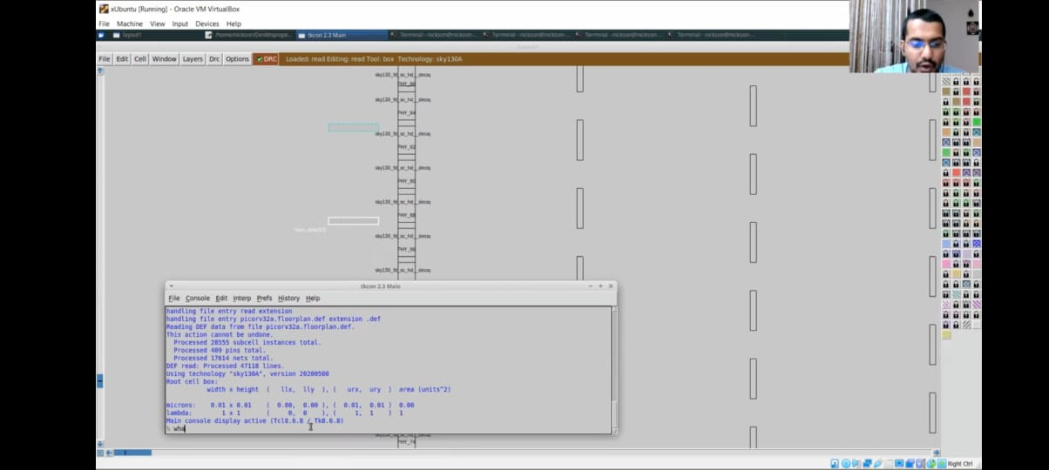

*Refer to this pics which are done by those links from the above*

***Cell design and characterization flows :-***

*All cells such asAND, OR, BUFFER, INVERTER, flip-flops etc are present in standard cell library. The cells inside the library are of different flavors. The cell size is more, then the drive strength is high to drive longer wires. The threshold voltage is high, then it will take more time to switch than if one lesser threshold voltage.*

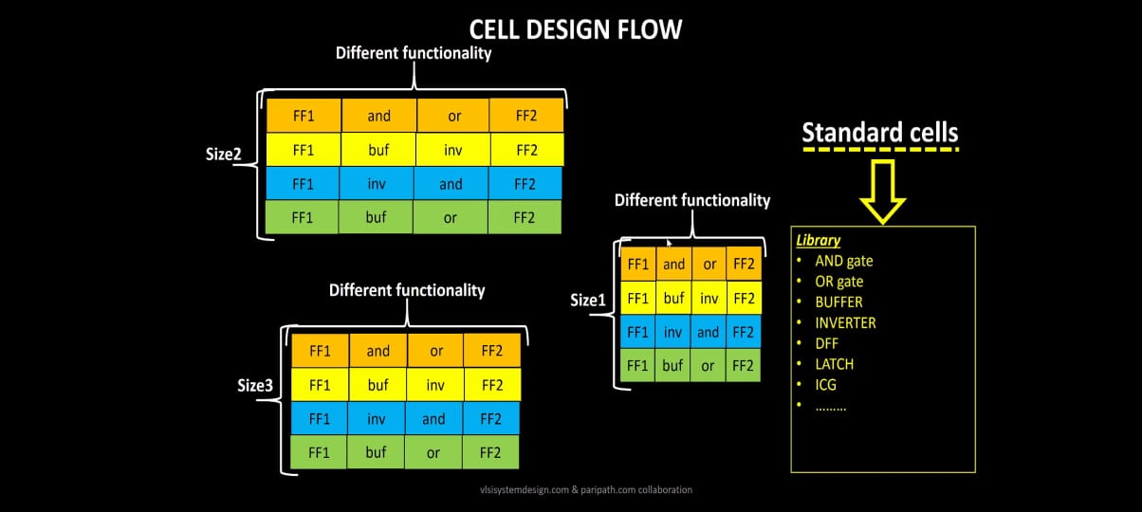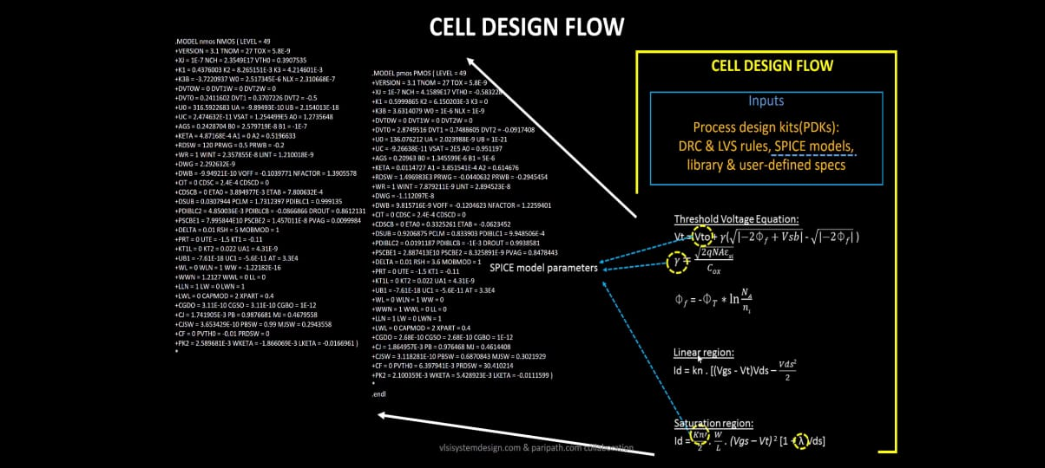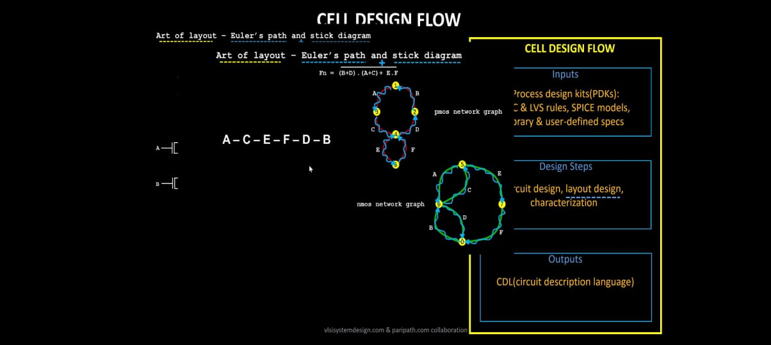

*Some of pics of cell design flow*

***DRC & LVS Rules****:-*

*Some of the Tech files and poly substrate parameters as following:-*

*• SPICE Models:*

*• User defined Spec:*

*• The standard cell library makers should follow the rules to avoid the errors*

*• Circuit design is done modeling the pmos and nmos to meet input library requirement*

*• Layout design is done using Euler's path and stick diagram on Magic layout too*

*Follow these Steps of characterization flow to complete:-*

*Read the spice model files and extract spice netlist*

*State the buffer behavior*

*Read the subcircuits*

*Paste the requires power sources*

*Attach the stimulus*

*GIVE REQUIRED capacitance FOR OUTPUT*

*GIVE simulation CODE/COMMAND*

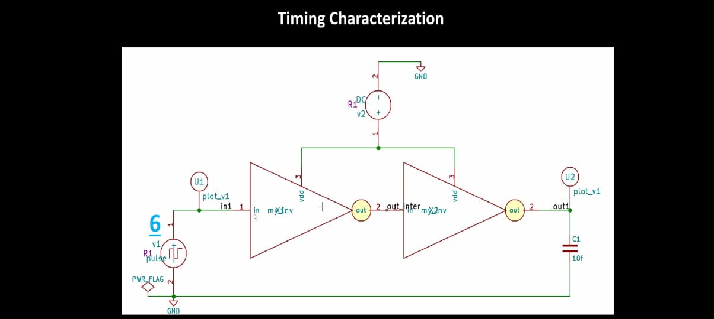

*IT IS THE TIMING OF THERSHOLD OR CHARACTERIZATION*

